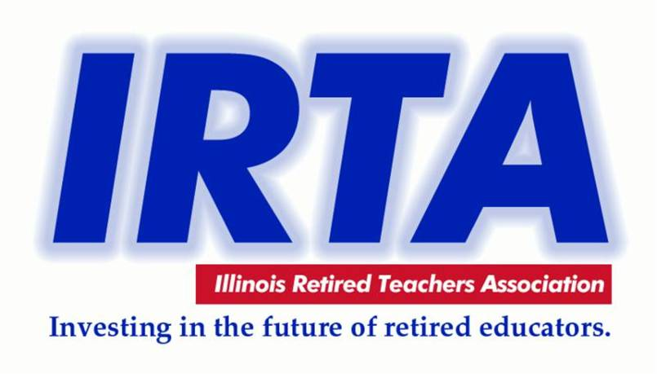 CLINTON COUNTY RETIRED TEACHERS ASSOCIATION
MEETING ON SEPTEMBER 5, 2019 @ TRENTON HOUSE RESTAURANT
IN TRENTON, IL AT 11:30 A.M.
CCRTA Webpage: www.ccrta@weebly.com
AGENDA
- Welcome --- Kelley J. Kesterson, CCRTA President
- Pledge of Allegiance
- Introduction of Officers of CCRTA for 2019
- Prayer & Ordering from Menu
- Introduction of Guests Attending and New Members at this Meeting: (ROE 13 Representative)
- Report from IRTA Region 16 Director Donnie Ostrom
1. IRTA Convention in October 14th and 15th
2. Attendees from CCRTA to Convention: Don, Kay, & Kelley
OLD BUSINESS REORT:
- Secretary’s Report - Minutes of June 1, 2017 Meeting – Kay Ostrom
- Treasurer’s Report – Janice Kauling
A. Collecting CCRTA Dues for 2019 - $10.00
B. Pay at Meeting or Mail to: Janice Kauling
1280 15th St.
Carlyle, IL 62231
GUEST REPORT/SPEAKER/PROGRAM:
- Regional Superintendent’s Office – Ron Daniels/Melanie Andrews
NEW BUSINESS:
- President’s Report and Business
- Convention Year and Gift Basket (Theme)/delegates from CCRTA/Unit Honoree
B. Candidates for CCRTA Officers for 2019 – 2020
C. Introduction of Marie Bair & Family – CCRTA Lifetime Educator Award 2019
- Health and IP – Updates on current members unable to attend or Ill
- Legislative Report– Kelley Kesterson
- Membership Report– Mary Ann Kauling
- Foundation Report - Cynthia O’Neill
- The Foundation Fund Basket is on the Table for Donations from Members

Close of Meeting
NEXT MEETING: THURSDAY, DECEMBER 5, 2019 AT BRETZ’S WINERY IN CARLYLE, IL @ 11:30 A.M.

