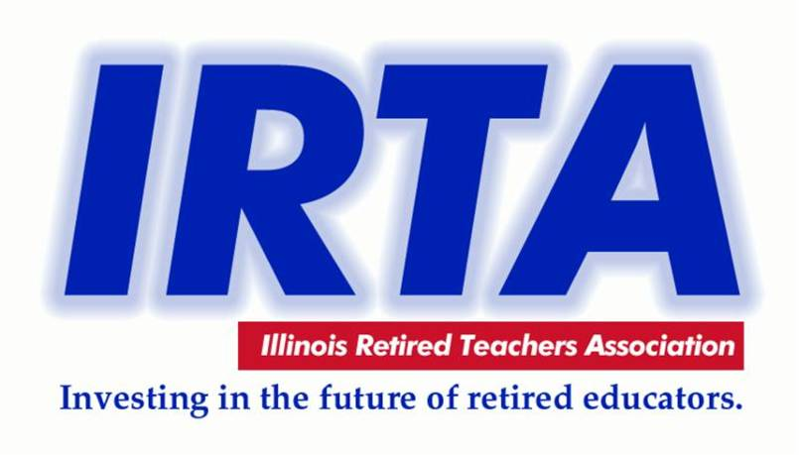 CLINTON COUNTY RETIRED TEACHERS ASSOCIATION
Meeting on December 5, 2019 @ Bretz Winery
Carlyle, IL @ 11:30 A.M.
CCRTA Webpage: www.ccrta@weebly.com
AGENDA
- Welcome --- Kelley J. Kesterson, CCRTA President
- Pledge of Allegiance
- Prayer
- Introduction of Guests Attending this Meeting: (ROE 13 Representative, CHS Music Students, visitors, new members)
- Carlyle HS Bands performance, Mrs. Jamie Zettler Furrow-Dir. & Ordering from Menu/Fellowship with fellow members
OLD BUSINESS REORT:
- Secretary’s Report - Minutes of September 5, 2019 Meeting – Kay Ostrom(newsletter)
- Report from IRTA Region 16 Director Donnie Ostrom
- Treasurer’s Report – Janice Kauling
A. Collecting CCRTA Dues for 2020 - $10.00
B. Pay at Meeting or Mail to: Janice Kauling
1280 15th St.
Carlyle, IL 62231
GUEST REPORT/SPEAKER/PROGRAM:
- Regional Superintendent’s Office – Ron Daniels
- NEW BUSINESS:
- President’s Report and Business
- Election of Officers: 2020-21
- Report & Summary of IRTA Convention
- Health and IP – Updates on current members unable to attend or Ill
- Send letter to three retired friends that don’t belong to CCRTA and IRTA
- Legislative Report– Kelley Kesterson
- Membership Report– Mary Ann Kauling
- Foundation Report - Cynthia O’Neill
- DOOR PRIZE DRAWING!!!
- Any other new business
Close of Meeting: MERRY CHRISTMAS TO ONE AND ALL!
NEXT MEETING: THURSDAY, March 5, 2020 - Trenton House @ 11:30 AM Guest Speaker: TBA

